Pinging PC1 to PC2 &PC3

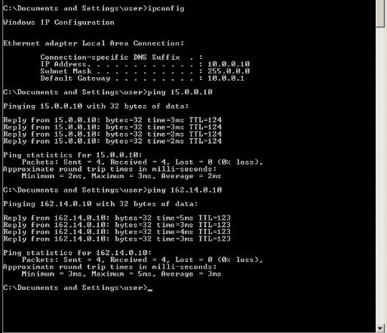

Pinging PC2 to PC1 & PC3
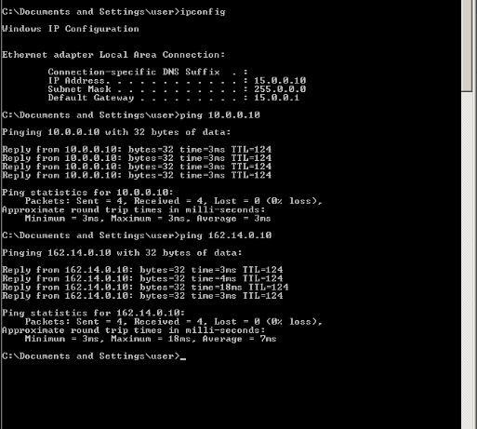

Pinging PC3 to PC1 & PC2

